**.Net Core  
  
Get**: <https://localhost:44373/api/Employee/GetEmployee>  
  
**Post**: <https://localhost:44373/api/Employee/PostEmployee/> (with [FromBody])  
(Add **NEW** value from postman🡪body🡪Jason)  
[https://localhost:44373/api/Employee/PostEmployee/?EmployeeName=Jack](https://localhost:44373/api/Employee/PostEmployee/?EmployeeName=Jackg) (without [FromBody])

**Put**: <https://localhost:44373/api/Employee/PutEmployee/?id=1> (with [FromBody])  
(Add **UPDATED** value from postman🡪body🡪Jason)  
  
[https://localhost:44373/api/Employee/PutEmployee/?id=1&& EmployeeName =Jackson](https://localhost:44373/api/Employee/PutEmployee/?id=1&&UpdatedName=Jackson)

(without [FromBody])

**Delete**: <https://localhost:44373/api/Employee/DeleteEmployee/?id=2>  
  
  
  
  
**How to create Database Code first approach .Net Core**  
<https://www.youtube.com/watch?v=K6hlWvhW_nU>  
  
  
**ASP.NET CORE Tutorial For Beginners**  
<https://www.youtube.com/watch?v=YIf_MIsHPNY&list=PL18HZjtdIA4CcOW9DeICmgk_VOnwhB8Cz>  
  
**ASP.NET FREMWORK Web API tutorial for beginners**<https://www.youtube.com/watch?v=0pcM6teVdKk&list=PL6n9fhu94yhW7yoUOGNOfHurUE6bpOO2b&index=1>  
  
  
**Short Key**  
Create Constructor : “ctor” double tab  
for implement: “Ctrl” “**.**”  
Create Controller : “ctor” double tab  
  
  
**Cmd in visual studio:**  
  
PM> add-migration Init  
PM> update-database  
  
  
  
[**Get ConnectionString from appsettings.json instead of being hardcoded in .NET Core**](https://stackoverflow.com/questions/45796776/get-connectionstring-from-appsettings-json-instead-of-being-hardcoded-in-net-co)   
{

"ConnectionStrings": {

"DefaultConnection": "Server=**YOURSERVERNAME**; Database=**YOURDATABASENAME**; Trusted_Connection=True; MultipleActiveResultSets=true"

},  
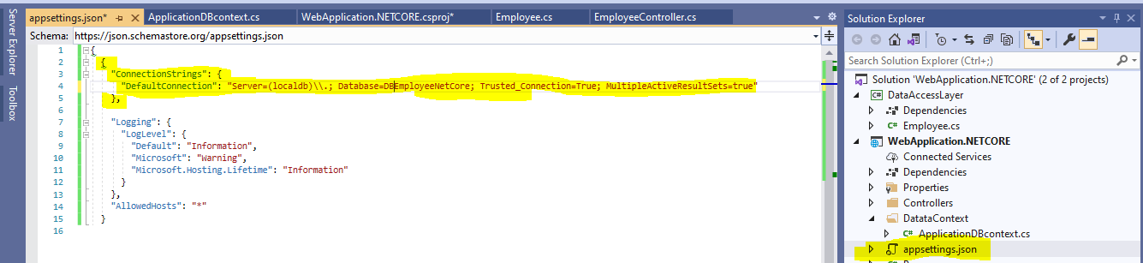  
  
Adding Service **in Startup.cs** file  
  
services.AddDbContext<ApplicationDBcontext>(Options => Options.UseSqlServer(Configuration.GetConnectionString("DefaultConnection")));  
